Upon completion of this session, students should be able to:
- Comprehend the structural nature of HTML documents
- Use this structure to create valid / functional HTML markup
- Recognise valid HTML tags and their function
- Utilise a variety of tools available within a HTML editor (Notepad++)
- Use a variety of valid tags to structure content
- Recognise deprecated tags and the nature of their obsolescence (CSS)

The following exercises are designed to increase your familiarity with the structure and syntax of HTML documents and the use and function HTML Tags.

NB This tutorial/practical and work you undertake forms part of TASK 3

EXERCISE 1: HTML Document Structure Page 2
Re-order the basic HTML tags to ensure that they are in the correct sequence
Missing tags also need to be added

EXERCISE 2: HTML Document Structure (nesting tags) Page 3
Re-order the sequence in which the tags are nested so that they are rendered correctly by the browser

EXERCISE 3: HTML Tag Quiz Page 4
Identify commonly used tags and give a description of the function(s) which they perform

EXERCISE 4: Deprecated HTML Tag Quiz Page 6
Identify 3 examples of deprecated tags and provide an example of current alternatives

EXERCISE 5: Doc Type Declarations Page 7
Identify the difference between Doc Type Declarations and state what the significance of this difference is for they HTML you create

EXERCISE 6: Meta Tags and Keywords Page 8
Add Meta Data to a document in order to reflect that the content of the site is based around the topic of “University Life”

Using Notepad Page 9
Use Notepad to create / edit and save HTML documents

Using W3SCHOOLS to Preview HTML Page 11
Add relevant content and extra tags to create a coherent HTML document

Self-Study: Adding Content and Further Tags Page 12

EXERCISE 1: HTML DOCUMENT STRUCTURE

Document 1 is incorrectly structured (tags in wrong order within the document) and there are tags missing. The document will not, therefore, work correctly when interpreted by a browser. Copy and paste the tags into Document 2 in so that the tags are in the correct order and the missing tags have been replaced and then copy your code from document 2 into Notepad to test it.

DOCUMENT 1 Unstructured
<!DOCTYPE HTML PUBLIC "-//W3C//DTD HTML 4.01//EN"
"http://www.w3.org/TR/html4/strict.dtd">
</body>
<title>Creating HTML for CT4009 Portfolio using Notepad</title>
</head>
<p>Hello <b>world!</b><p>
</html>
<p>This task is part of the tutorial for week 3 of CT4009
<head>

DOCUMENT 2 Structured
<!DOCTYPE HTML PUBLIC "-//W3C//DTD HTML 4.01//EN"
"http://www.w3.org/TR/html4/strict.dtd">

<head>
<title>Creating HTML for CT4009 Portfolio using Notepad</title>
</head>
</body>
<p>Hello <b>world!</b><p>
<p>This task is part of the tutorial for week 3 of CT4009</p>
</body>

</html>

EXERCISE 2: HTML TAG NESTING

Document 1 is also incorrectly structured. Although the tags are in the correct order, they are nested incorrectly. Copy and paste the tags into Document 2 so that the tags are correctly nested and then copy your code from document 2 into Notepad to test it.

DOCUMENT 1 Incorrect Nesting
<!DOCTYPE HTML PUBLIC "-//W3C//DTD HTML 4.01//EN"
"http://www.w3.org/TR/html4/strict.dtd">
<html>
<head>
<title><h1>Creating HTML using Notepad</title></h1>
</head>
<body>
<p>Hello <b>world! <p></b>
<p><h2>This task is part of the tutorial for week 3 of CT4009<p></h2>
</body>
</html>

DOCUMENT 2 Correct Nesting
<!DOCTYPE HTML PUBLIC "-//W3C//DTD HTML 4.01//EN"
"http://www.w3.org/TR/html4/strict.dtd">
<html>
<head>
<title><h1>Creating HTML using Notepad</h1></title>
</head>
<body>
<p>Hello <b>world! </b></p>
<p><h2>This task is part of the tutorial for week 3 of CT4009</h2></p>
</body>
</html>

NB Try to ensure that the subsequent tags which you use are nested in the correct order – always try to close the tags in the order in which they were opened.

EXERCISE 3: HTML TAG QUIZ

Identify the following tags and provide a brief explanation of their function.
NAME: | Opens the header |  | <head>
FUNCTION: | Sets off the title and other information that isn’t displayed on the web page itself |  | <head>

NAME: | Opens the body | <body>
FUNCTION: | Sets off the visible portion of the document | <body>

NAME: | Opens a paragraph | <p>
FUNCTION: |  | <p>

NAME: | Header 1 | <h1>
FUNCTION: | Creates the largest headline | <h1>

NAME: | Header 2 | <h2>
FUNCTION: | Creates the second largest heading | <h2>
NAME: | Bold | <b>
FUNCTION: | Defines bold text | <b>
NAME: |  | <br>
FUNCTION: | Defines a single line break | <br>

NAME: | emphasise | <em>
FUNCTION: | Defines emphasised text | <em>

NAME: |  | <i>
FUNCTION: | Defines a part of text in an alternate voice or mood | <i>

NAME: | Title | <title>
FUNCTION: | Defines a title for the document | <title>

NAME: | Unordered list | <ul>
FUNCTION: | Defines an unordered list | <ul>

EXERCISE 4: DEPRECATED TAGS

In the tables below, identify 3 examples of deprecated tags and provide examples of the tags which have replaced them.
DEPRECATED HTML | <basefont> | < basefont >
FUNCTION: | Sets font styles | < basefont >
REPLACEMENT | font style sheets | < >
FUNCTION: |  | < >

DEPRECATED HTML | menu | < menu >
FUNCTION: | Menu list | < menu >
REPLACEMENT | Unordered list | < ul >
FUNCTION: |  | < ul >

DEPRECATED HTML | center | <center >
FUNCTION: | Used to align text in the centre of the page | <center >
REPLACEMENT | Text-align:center | <<div style="text-align:center"> >
FUNCTION: | Used to align text within a div to being in the centre of the page | <<div style="text-align:center"> >
NB If you have identified a tag whose function is formatting (changing the appearance of content), the replacement code is likely to be CSS
EXERCISE 5: DOCTYPE DECLARATIONS

Identify the difference between Document 1 and Document 2 and say what the implications of this difference are for the code which you write.

DOCUMENT 1
<!DOCTYPE HTML PUBLIC "-//W3C//DTD HTML 4.01//EN"
"http://www.w3.org/TR/html4/strict.dtd">
<html>
<head>
<title>Creating HTML using Notepad</title>
</head>
<body>
<p>Hello <b>world!</b><p>
<p>This task is part of the tutorial for week 3 of CT4009<p>
</body>
</html>
DOCUMENT 2
<!DOCTYPE HTML >

<html>
<head>
<title>Creating HTML using Notepad</title>
</head>
<body>
<p>Hello <b>world!</b><p>
<p>This task is part of the tutorial for week 3 of CT4009<p>
</body>
</html>
DOCUMENT 1
SIGNIFICANCE/IMPLICATIONS FOR CODE
Html 4.01 will only allow you to use the elements associated with it

DOCUMENT 2
SIGNIFICANCE/IMPLICATIONS FOR CODE
Html allows you to use elements in html 4.01 aswell as the new elements of html 5

EXERCISE 6: META DATA

Insert Meta Data into the document below in order that it reflects content based upon the topic “University Life”.
<-- For speakers of US English --> <META name="keywords" lang="en-us" content="University, CT4009, Gloucestershire,HTML ">

<!DOCTYPE HTML PUBLIC "-//W3C//DTD HTML 4.01//EN"
"http://www.w3.org/TR/html4/strict.dtd">
<html>
<head>
<title>Creating HTML using Notepad</title>
</head>
<body>
<p>Hello <b>world!</b><p>
<p>This task is part of the tutorial for week 3 of CT4009<p>
</body>
</html>

Using Meta Data, you can describe the key topics of a website, or provide an abstract of its content.

By thoughtfully summarising the content of a page, you provide the end user with a much better indication of whether the site is likely to be of interest.
Meta Data is added to the document using the following syntax:

<meta name=“type of info” content=“details”>
Some examples of contextually sensitive Meta Data are shown below:

<-- For speakers of US English --> <META name="keywords" lang="en-us" content="vacation, Hawaii, beaches ">

<-- For speakers of British English --> <META name="keywords" lang="en" content="holiday, Spain, sunshine">

<-- For speakers of French --> <META name="keywords" lang="fr" content="vacances, Sardinia, soleil">

NB Ensure that you place the Meta Data into the correct section of the document and that you understand the function of <-- -->
USING NOTEPAD ++

Launch Notepad on your computer, by going to Start > Programs >
Notepad ++.

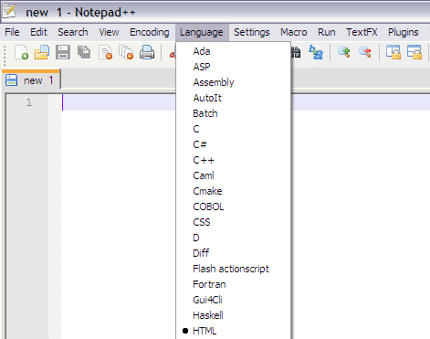

You can choose the default language which you are going to edit in – this should be HTML.

You should be able to see that your saved file is represented by an HTML document icon relating to the default browser setting of the machine to which it is saved.

NB if you cannot see an icon relating to the browser, you have probably saved the file without the correct (.html) extension.

You can save your files either with an .htm or an .html extension. As long as you are consistent with the naming of your files, it does not really matter. However, it is recommended that you use the .html extension for your naming conventions.
The save icon is red if you have made changes to the document and need to save them. Once you have, the icon turns to blue.
Notepad ++ creates line numbers in order to make it easier to organise code.
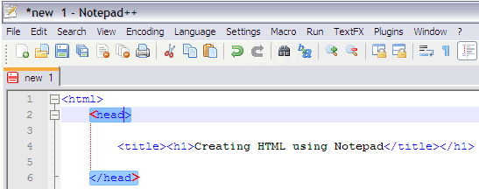
In addition, when you click inside a tag, Notepad shows you the corresponding tag (as illustrated above).
By choosing Settings > Preferences you can ensure that line numbers and highlighting are switched on.
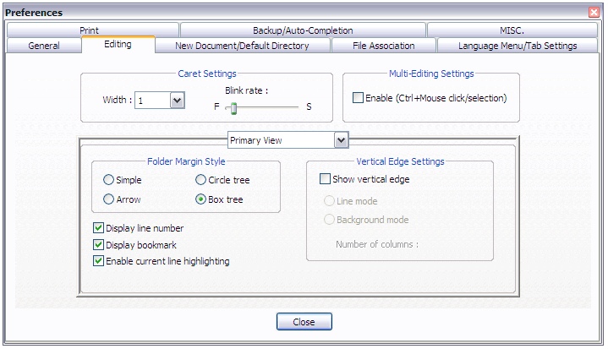
NB Notepad is very forgiving and will execute (run) your documents in the browser despite errors such as missing (unpaired) tags. You must not assume that your mark-up is correct and functional because of this.
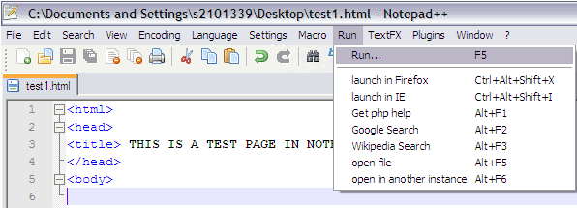

USING W3SCHOOLS TO PREVIEW HTML
Changing and previewing the html you create can be time consuming when using Notepad. It makes sense to test and preview your code before saving it in order to ensure that it is working correctly.

W3Schools allows you to do this quickly and effectively. You can cut and paste or type your HTML and content into the preview window. Click “Try it yourself” to open the edit and preview window.

http://www.w3schools.com/html/html_intro.asp
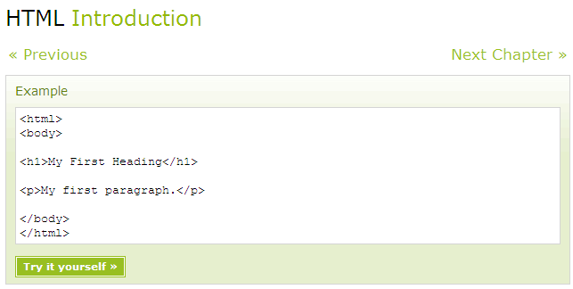
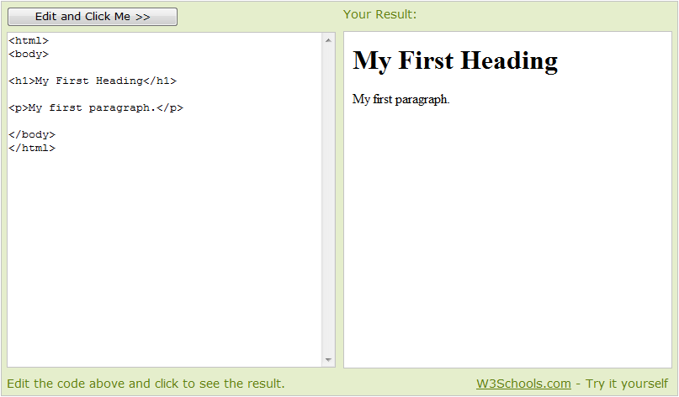
Using this facility, you can edit and preview your code before taking it back into Notepad and saving it as a HTML file.

SELF-STUDY: ADDING CONTENT AND FURTHER TAGS
Use the tags provided below (as well as those identified in the Tag Quiz on page 4) to format the content (text) that you add to reflect the topic of Assignment 1.

<!DOCTYPE HTML PUBLIC "-//W3C//DTD HTML 4.01//EN"
"http://www.w3.org/TR/html4/strict.dtd">
<html>
<head>
<title>Creating HTML using Notepad</title>
</head>
<body>
<p>Hello <b>world!</b><p>
<p>This task is part of the tutorial for week 3 of CT4009<p>
</body>
</html>

<p> | <b> | <br> | <i> | <h1> | <h2> | <em>

You should also take screengrabs of your HTML documents (as rendered via a browser) and save these in order that they can be utilized within your evaluation. The illustration and discussion of code can be difficult to present effectively, so ensure that you have looked at the Portfolio Guidelines available under resources on the module website.

If you have successfully completed the Tutorial Exercises, you could spend the remaining study time reading the recommended textbook. Alternatively, you could review this week’s lecture notes or look ahead to next week’s topics. Remember that you are free to use the labs as long as they are not booked for another lesson; they tend to be very quiet early in the morning and in the evenings!

It is important that you read through the module guide several times throughout the semester so that you have a thorough understanding of the requirements of the module, particularly the assignments.

Starting planning for assignment 1 by considering things such as what media you may already have that could be included, e.g. photographs etc. Are these available locally? Do they need to be scanned or digitised? If you do not have your own digital camera or camcorder you should think about borrowing these from the technicians – plan for this by booking in advance. Also, it would be appropriate to keep a written diary of your html / authoring experiences so that you can use them later on in the assignment and include them in your evaluation document. This could be rough notes, sketches or possibly screen shots, add to them as thoughts come to mind – it is too easy to forget excellent ideas you had late at night or early in the morning!

NB: If you did not manage to complete all of the tutorial exercise in the time available during your allotted lab session, you must endeavor to catch up during the self-directed study time.

